October 7th, 2007
Hi
The Rugby World Cup quarter finals are being held this weekend. Of the two matches played so far, both have been sensational upsets to say the least. First Australia (ranked 2), were just beaten by England 12-10. Then France just beat NZ (the favourites) 20-18. So the two top teams are out of the tournament and on their way home. I saw a little of the Australia game but as the NZ game was at 3 am (HK time) I did not watch it. So, now in three world cup tournaments, the All Blacks, though favourites, have failed and yet in the years between the world cups they are virtually unbeatable. So I would now expect the cup to be won by South Africa.

Last Monday, October 1st, was the National day holiday. There were the usual evening fireworks over the harbour. This past week, I had just two swims but did 1.8 km each time so the total distance was the same as for past weeks when I had three swims and did 1.2 km each time. The swims this week felt very good too. The HK Rugby Football Union announced the price of the tickets for next year’s 7s tournament are to be HK$1080, up 23% from last year. Quite expensive.
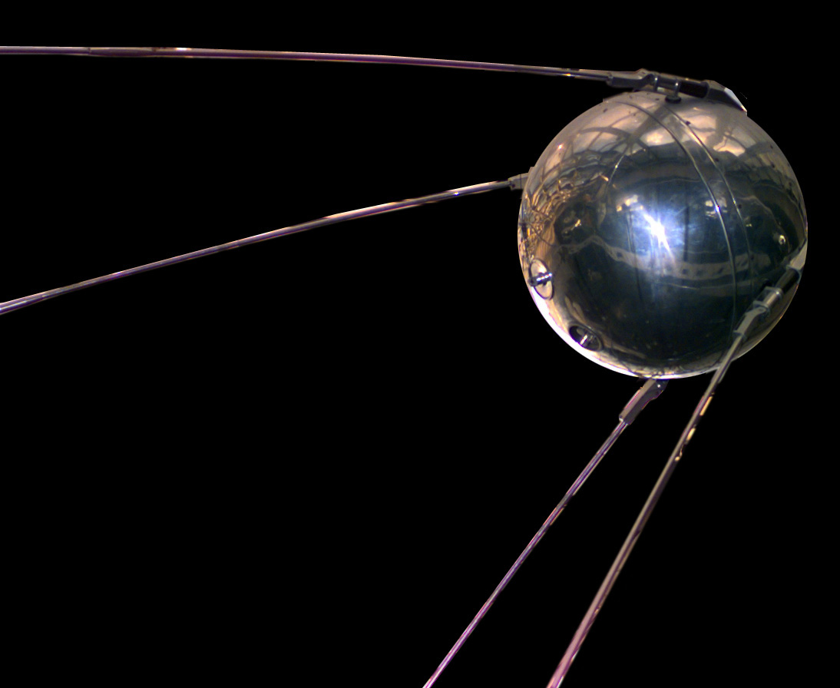
Last Thursday was the 50th anniversary of the launch, by Russia, of the first satellite, named ‘Sputnik’. I was in my last year at school at the time and remember it very clearly. On nights when it crossed our skies, we would go to school to observe it – just a small faint star which appeared to move somewhat erratically. This event, along with the introduction of personal computers, was probably one of the most technologically significant of the last century.

When I was reading yesterday’s newspaper, I saw an advertisement by Cathay Pacific for a much cheaper ticket to San Francisco than the one I bought. It was only HK$4200 compared with the $5400 I paid (both before taxes are added). However, it probably does not include air miles (as my UA ticket does) and even if it did these would not be much use as Cathay Pacific is not a Star Alliance member, whose airline I use most often.
I got an e-mail from Wendy saying they will be arriving in SFO on the morning of the November 15th and staying at Quality Suites Millbrae.
That’s about it for this time.
Cheers

